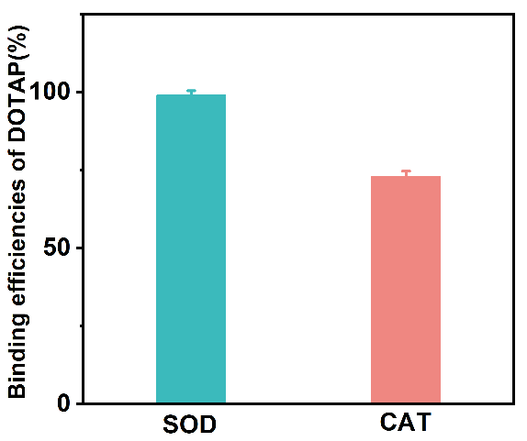
Supplementary Fig. 1. The binding efficiencies of DOTAP to SOD and CAT. n=3.

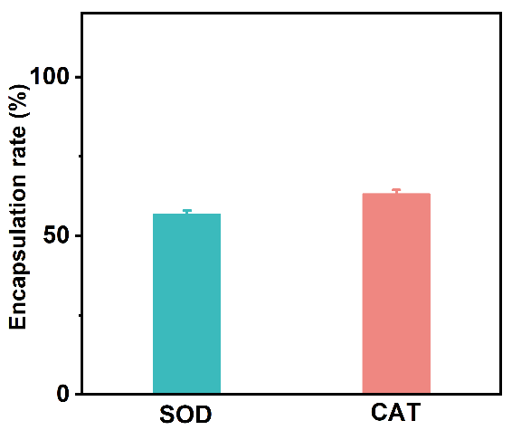
Supplementary Fig. 2. The encapsulation rate of SOD and CAT in liposomes. n=3.

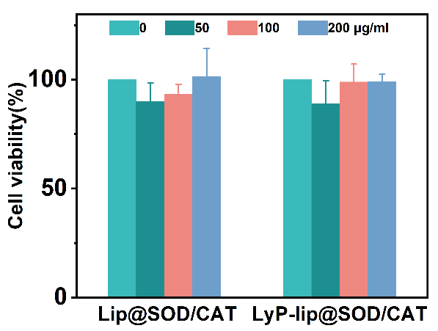
Supplementary Fig. 3. Cytotoxicity of Lip@SOD/CAT and LyP-lip@SOD/CAT by MTT assay. n=3.

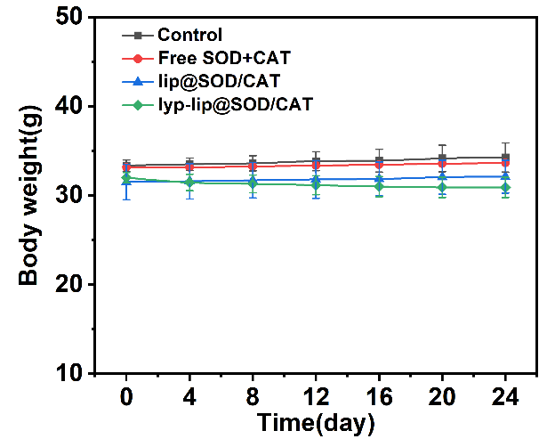
Supplementary Fig. 4. Body weight of mice in different groups. n=3.

